X-Gurlesque
JangPa

October 12th – November 9th, 2017
Opening Reception: October 12th, Thursday 6 – 8 PM
DOOSAN Gallery New York, 533 W 25th St., New York, NY 10001

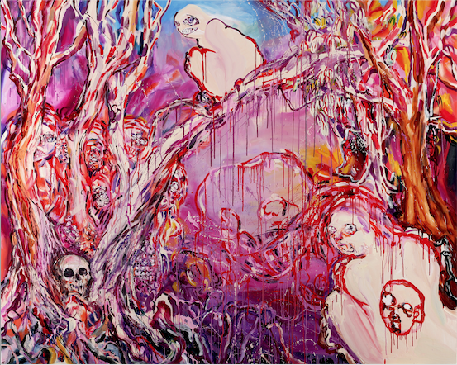
My Little Riot Girl, 2015. Oil on canvas, 71.6 x 89.5 inches
DOOSAN Gallery New York is pleased to announce "X-Gurlesque," the solo exhibition of JangPa, which is open to the public from October 12th through November 9th, 2017.

JangPa examines the inescapable roles of the artwork and its viewer—i.e. object and subject—and examines the idea of a “mutual gaze” through her paintings of powerful palette and grotesque imagery.

The term “Gurlesque” from the exhibition title—a combination of “New Grrly,” “grotesque,” and “burlesque,”—was originally coined by feminist poet and writer, Arielle Greenberg, to describe writers who perform femininity in their work in a campy or mocking manner*. JangPa shares the poets’ intent to break away from feminine stereotypes through her paintings of grotesque and uncanny imagery. The exhibition presents the viewers a sensual experience through its unconventional layout and use of space.

The Fluid Neon (2016) series and Brutal Skins (2017) series are displayed along the fluorescent red wall that extends inward from the gallery’s entrance. Brutal Skins is a wall installation series that is inspired by the “female monster” and the significance and appearance of her uterus. This series reiterates the female body as a distorted monster, thus criticizing the traditional consumption of the female body as “the object for desire.” Furthermore, feminine figures are heralded as “the subject that desires” through the work. On the other hand, the Fluid Neon paintings, whose liquid textures are amplified, reflects the form of a meager and passive fetus. Contrasting the “female monster,” the fetus embodies a dual significance as both subordinate and threatening to the mother figure.

The centerpiece that one encounters upon entering the space, My Little Riot Girl (2015), embodies relatively landscape-like features compared to Fluid Neon. The painting includes the artist’s self-portrait and her cynical gaze, the ultimate challenge that viewers are confronted with after a course of brutal criticism and mystical reinterpretation. The artist claims that the crouching figure with a smile in the upper corner of the painting is, in fact, herself. Consequently, the artist and viewers exchange gazes, or engage in mutual voyeurism, through the surface of the canvas. The artist’s gaze here can be interpreted in various ways, while it strongly foreshadows the intent behind the layers of brushstrokes.

*From Gurlesque: the New Grrly, Grotesque, Burlesque Poetics. Edited by Arielle Greenberg and Lara Glenum. Saturnalia Books, 2010.

JangPa (b. 1981) received her M.F.A. in Painting from Seoul National University, where she received her B.F.A. in Painting and Aesthetics. She has held solo exhibitions at SOMA Drawing Center (2016, Seoul, Korea), Makeshop Art Space (2015, Paju, Korea), Gallery Zandari (2015, Seoul, Korea), TV12 Gallery (2013, Seoul, Korea), OCI Museum of Art (2011, Seoul, Korea), and Alternative Space Hut (2009, Seoul, Korea). She has also participated in group exhibitions at venues that include Art Space Pool (2017, Seoul, Korea), Seoul Museum of Art (2015, Seoul, Korea), DOOSAN Gallery Seoul (2015, Seoul, Korea), OCI Museum of Art (2015, Seoul, Korea), Gallery Button (2015, Seoul, Korea), BMOCA (2015, Paju, Korea), DOOSAN Gallery Seoul (2014, Seoul, Korea), Common Center (2014, Seoul, Korea), and Hangaram Art Museum, Seoul Arts Center (2011, Seoul, Korea).

